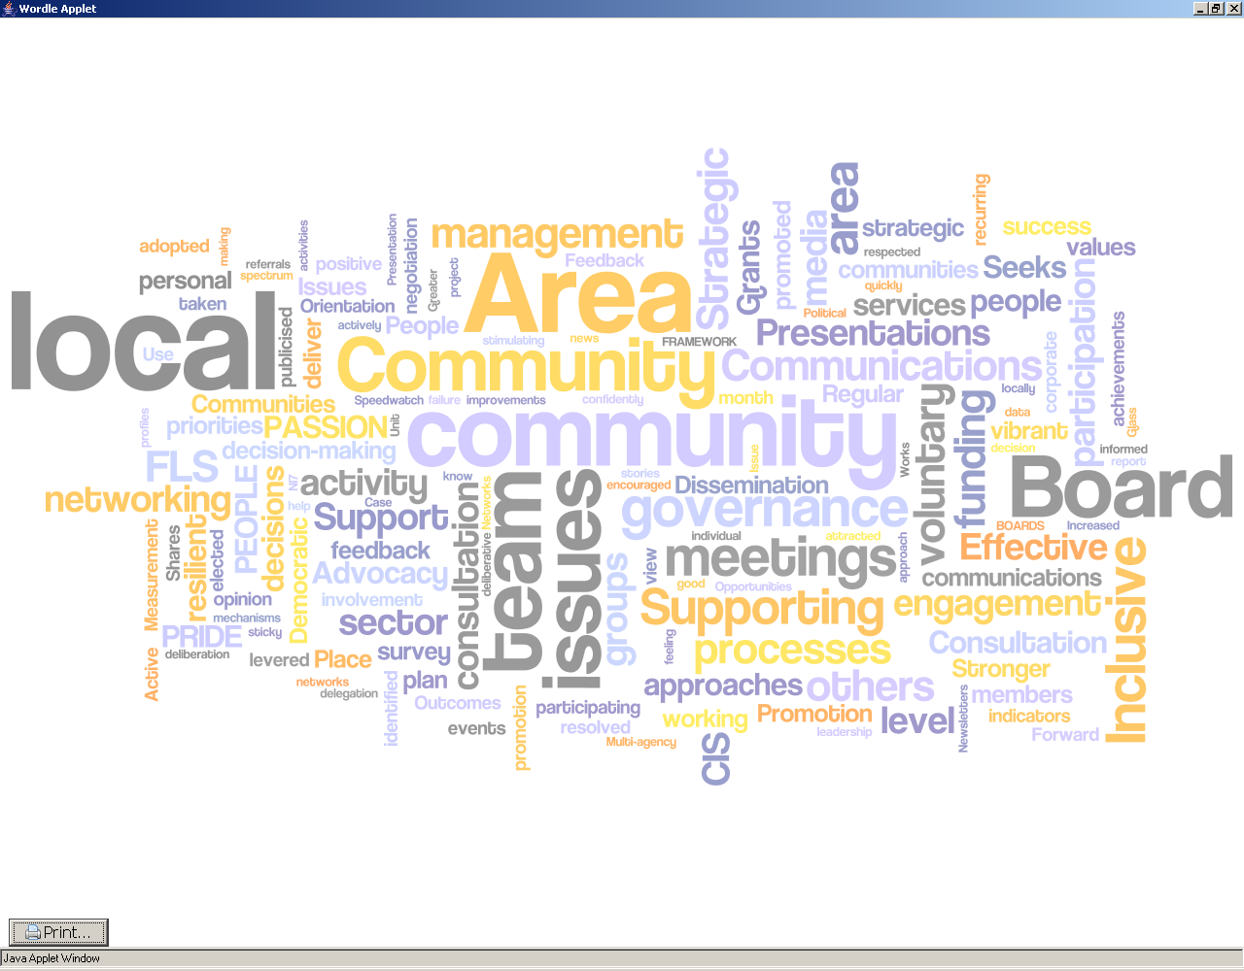


Area Boards in Wiltshire
Outcomes Framework

AREA BOARDS: OUTCOMES FRAMEWORK 2009/2010
Strategic Outcomes | Supporting Aims | Supporting Activities | Measures and Targets
Local Communities that can develop and deliver their own priorities and improvements | - People know how to report local issues | - Effective promotion of the Community Issues System (CIS) | - Number of issues received per month
 | - Issues resolved quickly at the most local level | - Effective management of CIS tracking database | - % issues resolved each cycle
 | - Multi-agency problem solving approach for ‘sticky’ issues | - Appropriate issue referral  - Partnership networking | - % issues with multi agency input.
 | - Communities in control | - Transfer of assets and powers | - % of requests approved
Organisations in Wilts working together to plan and deliver services | - Strategic issues are identified and addressed in partnership | - Effective monitoring of CIS to identify recurring themes that need a coordinated strategic response | - No of recurring issues identified per month
Stronger and more resilient communities | - More people participating in local democratic processes | - Inclusive AB meetings  - Inclusive local consultation activity  - Inclusive engagement activity  - Inclusive communications | - Attendance at Area Board meetings
Stronger and more resilient communities | - More decisions taken locally | - Maximum delegation of decision making to local level | - % of Area Board agenda items resulting in decisions
Stronger and more resilient communities | - Increased transparency in decision-making | - Wide range of communications mechanisms adopted  - Production of area newsletters  - Forward plan, up to date and promoted | - JaM distribution  - CAN membership
Stronger and more resilient communities | - Greater deliberation in local decision-making | - Use of deliberative approaches at Area Board meetings  - Use of targeted consultation events | - No. of people participating at Area Board meetings and consultative events
Stronger and more resilient communities | - People feeling they can influence local decisions | - Deliberative approaches used at Area Board meetings  - use of voting handsets and tests of local opinion on issues  - Meaningful consultation and feedback | - Annual Area Boards Survey.  - National indicator Ni4 measured by Place Survey
Stronger and more resilient communities | - Removal of barriers to participation | - Active engagement with wide spectrum of community groups  - Equal opportunities for participation | - Profile of participants  - NI 3 & 4 measured by place survey

Strategic Outcomes | Supporting Aims | Supporting Activities | Measures and Targets
Stronger and more resilient communities (cont) | - Opportunities for involvement are publicised and promoted | - Newsletters  - Community Area Networks  - Social networking and eDemocracy | - JaM distribution  - CAN membership
Stronger and more resilient communities (cont) | - More informed local community | - Regular updates to local people  - Dissemination of area profiles  - Presentations for community groups | - JaM distribution  - CAN membership
Stronger and more resilient communities (cont) | - More positive view of Council and partners | - Place survey  - Promotion of good news stories  - Case studies | - Measurement of Ni4 by Place Survey  - Analysis of Place Survey by Community Area  - Annual Area Boards Survey
Stronger and more resilient communities (cont) | - Councillors confidently undertaking their community leadership roles | - Support to local elected members  - Issue referrals | - Feedback from elected members and by local survey
Stronger and more resilient communities (cont) | - Improved corporate working | - Engagement of Frontline services  - Dissemination of service and budget data to area level  - Presentations and networking for FLS | - Annual Area Boards Survey  - Analysis of Place Survey by Community Area
Stronger and more resilient communities (cont) | - Grant funding acts as a catalyst for stimulating community activity and delivering community priorities | - Support to grant applicants  - Promotion of Grants Scheme | - No of projects supported
Stronger and more resilient communities (cont) | - External funding attracted and levered in | - Grants advice and signposting  - Bidding for strategic project funding – such as ‘Speedwatch’ | - Amount of funding and voluntary contributions levered in through grants scheme
 | - Community Area Partnerships actively coordinating activity and promoting community projects | - Funding for CAP core costs  - Community planning process  - Project funding | - CAPA assessment process with WfCAP  - Community plan progress  - No. of projects sponsored
A Strong, vibrant and active voluntary sector | - A vibrant voluntary sector, actively engaged | - Development of community area networks  - Regular communication and engagement directly and through VCS Support Unit | - No of voluntary and community groups signed up for CAN.  - Measurement and feedback from Ipsos Mori poll and measurement of Ni7

AREA BOARDS TEAM: COMPETENCIES FRAMEWORK
Strategic outcomes | Supporting aims | Supporting activities | Required competencies
Local Communities that can develop and deliver their own priorities and improvements | - People know how to report local issues | - Effective promotion of the Community Issues System (CIS) | - Area Board processes  - Communications and media
 | - Issues resolved quickly at the most local level | - Effective management of CIS tracking database | - Area Board processes  - FLS Orientation/corporate awareness  - Time management
 | - Multi-agency problem solving approach for ‘sticky’ issues | - Appropriate issue referral  - Partnership networking | - Area Board processes  - Mediation and negotiation  - FLS Orientation  - Research
 | - Communities in control | - Transfer of assets and powers | - As above
Organisations in Wilts working together to plan and deliver services | - Strategic issues are identified and addressed in partnership | - Effective monitoring of CIS to identify recurring themes that need a coordinated strategic response | - FLS Orientation  - Advocacy, mediation, diplomacy, conflict resolution, negotiation  - Project management
Stronger and more resilient communities | - More people participating in local democratic processes | - Inclusive AB meetings  - Inclusive local consultation activity  - Inclusive engagement activity  - Inclusive communications | - Presentation  - Consultation  - Advocacy  - Community governance
Stronger and more resilient communities | - More decisions taken locally | - Maximum delegation of decision making to local level | - Democratic governance  - Community governance
Stronger and more resilient communities | - Increased transparency in decision-making | - Wide range of communications mechanisms adopted  - Distribution of JaM newsletters  - Forward plan, up to date and promoted | - Area Board processes  - Democratic governance  - Communications and media
Stronger and more resilient communities | - Greater deliberation in local decision-making | - Use of deliberative approaches at Area Board meetings & consultation events | - Facilitation  - Consultation  - Community governance
Stronger and more resilient communities | - People feeling they can influence local decisions | - Deliberative approaches used at meetings  - use of voting handsets and tests of local opinion on issues  - Meaningful consultation and feedback | - Facilitation  - Consultation  - Community governance

Strategic outcomes | Supporting aims |  | Supporting activities |  | - Required competencies
Stronger and more resilient communities (cont) | - Removal of barriers to participation |  | - Active engagement with wide spectrum of community groups  - Active promotion of equal opportunities for participation |  | - Equalities & Diversity  - Advocacy, mediation, diplomacy, conflict resolution, negotiation  - Consultation  - Political management
Stronger and more resilient communities (cont) | - Opportunities for involvement are publicised and promoted |  | - Newsletters  - Community Area Networks  - Social networking and eDemocracy  - Presentations for community groups |  | - Communications and media  - Consultation  - Community governance
Stronger and more resilient communities (cont) | - More informed local community |  | - Regular updates to local people  - Dissemination of area profiles  - Presentations for community groups |  | - Communications and media  - Advocacy  - Community governance
Stronger and more resilient communities (cont) | - More positive view of Council and partners |  | - Place survey  - Promotion of good news stories  - Case studies |  | - Communications and media
Stronger and more resilient communities (cont) | - Councillors confidently undertaking their community leadership roles |  | - Support to local elected members  - Issue referrals |  | - Area Board processes  - Political management  - Democratic governance
Stronger and more resilient communities (cont) | - Improved corporate working |  | - Engagement of Frontline services  - Dissemination of service and budget data to area level  - Presentations and networking for FLS |  | - Corporate awareness  - Strategic Awareness  - FLS Orientation  - Project management  - MS Powerpoint and Presentation
Stronger and more resilient communities (cont) | - Grant funding acts as a catalyst for stimulating community activity and delivering community priorities |  | - Support to grant applicants  - Promotion of Grants Scheme |  | - Advocacy,  - Negotiation  - Communications and media
Stronger and more resilient communities (cont) | - External funding attracted and levered in |  | - Grants advice and signposting  - Bidding for strategic project funding – such as ‘Speedwatch’ |  | - Research  - Grants
 | - Community Area Partnerships actively coordinating activity and promoting community projects |  | - Funding for CAP core costs  - Community planning process  - Project funding |  | - Community Development  - Community Governance
A Strong, vibrant and active voluntary sector | - A vibrant voluntary sector, actively engaged |  | - Development of community area networks  - Regular communication and engagement directly and through VCS Support Unit |  | - Community Development  - Community Governance  - Communications and media
Team ethos |  | Positive indicators |  | Negative indicators
● PEOPLE · PASSION · PRIDE ● PEOPLE · PASSION · PRIDE ● PEOPLE · PASSION · PRIDE ● PEOPLE · PASSION · PRIDE ● PEOPLE · PASSION · PRIDE ●
- High achieving  A high performing team continually striving for excellence |  | - Recognises the achievements of others  - Celebrates success of the team  - Seeks to exceed targets |  | - Blames others for failure  - Seeks personal glory  - Seeks to avoid being last
- Innovative  A team that is prepared to learn, experiment and test new ideas |  | - Learns from others  - Prepared to try new approaches  - Accepts risks |  | - Knows best  - Prefers the status quo  - Fears failure
- Empowered  Self resilient team members, acting upon individual initiative and taking the lead in their areas |  | - Seeks to solve problems  - Finds out  - Gets on with it |  | - Refers problems upwards  - Does it the way it has always been done  - Seeks permission
- Democratic  A team in which each individual is respected, taken seriously and encouraged to make a positive contribution |  | - Volunteers  - Gives an honest opinion  - Gets involved |  | - Lets others get on with it  - Says what they think they should  - Stands on the sidelines
- Supportive  Colleagues that trust, respect, help each other and put collective achievements above personal success |  | - Offers help  - Works with  - Shares team goals |  | - Competes  - Works alone  - Draws attention to personal successes
- Positive  A team with self belief and confidence in its ability to succeed |  | - Relishes a challenge  - Glass half full  - ‘Lets give it a go…’ |  | - Anticipates problems  - Glass half empty  - ‘But what if…’
- Open  A team in which differences are respected and critical challenge is encouraged |  | - Shares  - Tells it as it is  - Is open to persuasion |  | - Goes it alone  - Critical in private  - Adopts stubborn entrenched opinions
- Inclusive  A team in which equality, diversity and social inclusion are essential criteria for success |  | - Challenges injustice  - Mindful of the needs & views of minorities  - Accommodates difference |  | - Turns a blind eye  - Takes the majority view  - Goes with the flow
- Ethical  A team committed to achieving the highest standards of ethical conduct and upholding the Council’s values |  | - Upholds ethical and corporate values  - Loyal to team ethos  - Emotionally intelligent |  | - Places expedience above values  - Self-serving and self-referential  - Judgemental
- Valued  A team that values, recognises and rewards individuals who contribute to collective success. |  | - Praises achievements of others  - Listens to and learns from others  - Wins for the team |  | - Highlights personal successes  - Criticises the efforts of others  - Plays by their own rules
- Fun  A team that is fun to be part of, engenders friendship, camaraderie, pride and passion. |  | - Encouraging  - Shares a joke and has a laugh  - Participates |  | - World-weary  - Head down  - Too busy

Area Boards in Wiltshire
Outcomes Framework

